**DATA STRUCTURES AND ALGORITHM**

**MUHAMMAD AWAIS(01-134232-114)**

**MUJTABA GULZAR SOOMRO(01-134232-114)**

**AITZAZ HASSAN(01-134232-114)**

**Employee Management System**

**Introduction:**

Employee Management System is based on a concept to store and generate all the records of the employees. This program is considered as a simple database of employees in an office, an organization where the user can store employees record easily as it is not time-consuming.

**Features:**

1. Add Record
2. Search Record
3. Edit Record
4. Modify Record
5. Display Record
6. Salary Record
7. Display Salary Record

**Objectives:**

 This project aims to simplify the task of maintaining records of the employees of Company. To develop a well-designed database to store employee information. The objective of this project is to provide a comprehensive approach towards the management of employee information.

**Purpose:**

Employee Management System is a distributed application, developed to maintain the details of employees working in any organization. The EMS has been developed to override the problems prevailing in the practicing manual system. It maintains the information about the personal and official details of the employees.

**C++ Concepts:**

The concepts that we have used in this project are

1. Queues
2. Linked List
3. File Handling
4. Classes
5. Structures
6. Conditional statements
7. Loops
8. Constructors

**Advantages:**

* Provide computerized system for maintaining records.
* More efficient & reliable.
* Less time consuming and easy to use.
* Huge data storage with less computer memory.
* Avoid Human errors & efforts for Maintaining daily data.
* Avoid Data manipulations.
* Also avoids Data inconsistency & redundancy.

**Limitations:**

* This software will run on a single pc
* Admin and Employee have to sit on the same pc
* No network connection
* No GUI (Graphical User Interface)

**CODE:**

**#pragma warning(disable : 4996)**

**#include <iostream>**

**#include<conio.h>**

**#include<fstream>**

**#include<Windows.h>**

**#include<time.h>**

**#include<string>**

**using namespace std;**

**struct Node {**

**string Emp_id, Name, Post, Department;**

**float salary;**

**Node* next;**

**Node* prev;**

**};**

**class Employee {**

**private:**

**Node* front, * rear;**

**public:**

**Employee();**

**void Introduction();**

**void Login();**

**void Menu();**

**void Insert();**

**void Search();**

**void Edit();**

**void Delete();**

**void Display();**

**void Salary();**

**void readsal();**

**};**

**Employee::Employee() {**

**front = NULL;**

**rear = NULL;**

**}**

**void Employee::Introduction() {**

**system("cls");**

**cout << "\n\n\n\n\n\n\n";**

**cout << "\t\t\t==================================";**

**cout << "\n\t\t\t==================================";**

**cout << "\n\n\t\t\t EMPLOYEE MANAGEMENT SYSTEM";**

**cout << "\n\n\t\t\t==================================";**

**cout << "\n\t\t\t==================================";**

**_getch();**

**}**

**void Employee::Login() {**

**p:**

**system("cls");**

**string user, pass;**

**cout << "\n\n";**

**cout << "\t\t\t======================";**

**cout << "\n\n\t\t\t LOGIN PANEL";**

**cout << "\n\n\t\t\t======================";**

**cout << "\n\n\nEnter USER NAME : ";**

**cin >> user;**

**cout << "\n\nENTER PASSWORD : ";**

**for (int i = 1; i <= 6; i++) {**

**pass += _getch();**

**cout << "*";**

**}**

**if (user == "Mujtaba" && pass == "123456") {**

**cout << "\n\n\n\t\t\tLOGIN SUCCESSFUL";**

**cout << "\n\n\n\t\t\tLOADING";**

**for (int i = 1; i <= 6; i++) {**

**Sleep(500);**

**cout << ".";**

**}**

**Menu();**

**}**

**else if (user != "MUJTABA" && pass == "123456") {**

**cout << "\n\nUSER NAME IS WRONG...";**

**}**

**else if (user == "AWAIS" && pass != "123456") {**

**cout << "\n\nPASSWORD IS WRONG...";**

**}**

**else if (user != "AWAIS" && pass != "1234") {**

**cout << "\n\nUSERNAME & PASSWORD ARE WRONG...";**

**}**

**_getch();**

**goto p;**

**}**

**void Employee::Menu() {**

**p:**

**system("cls");**

**int a;**

**cout << "\n\n\t\t\t============================";**

**cout << "\n\n\t\t\t EMPLOYEE CONTROL PANEL";**

**cout << "\n\n\t\t\t============================";**

**cout << "\n\n1: INSERT RECORD";**

**cout << " \n2: SEARCH RECORD";**

**cout << " \n3: EDIT RECORD";**

**cout << " \n4: DELETE RECORD";**

**cout << " \n5: DISPLAY RECORD";**

**cout << " \n6: SALARY RECORD";**

**cout << " \n7: DISPLAY SALARY RECORD";**

**cout << " \n8: EXIT";**

**cout << "\n\nENTER YOUR CHOICE: ";**

**cin >> a;**

**switch (a) {**

**case 1:**

**Insert();**

**break;**

**case 2:**

**Search();**

**break;**

**case 3:**

**Edit();**

**break;**

**case 4:**

**Delete();**

**break;**

**case 5:**

**Display();**

**break;**

**case 6:**

**Salary();**

**break;**

**case 7:**

**readsal();**

**break;**

**case 8:**

**exit(0);**

**default:**

**cout << "INVALID CHOICE....TRY AGAIN";**

**}**

**_getch();**

**goto p;**

**}**

**void Employee::Insert() {**

**p:**

**system("cls");**

**string id, n, p, d, Temp;**

**float sa;**

**cout << "\n\n\t\t\t===========================";**

**cout << "\n\n\t\t\t INSERT EMPLOYEE RECORD";**

**cout << "\n\n\t\t\t===========================";**

**cout << "\n\n EMPLOYEE ID: ";**

**cin >> id;**

**cin.ignore();**

**cout << "\n\n EMPLOYEE NAME: ";**

**getline(cin, n);**

**cout << "\n\n EMPLOYEE POST: ";**

**getline(cin, p);**

**cout << "\n\n EMPLOYEE DEPARTMENT: ";**

**getline(cin, d);**

**cout << "\n\n EMPLOYEE SALARY: ";**

**cin >> sa;**

**fstream a;**

**a.open("Employee Record.txt", ios::in);**

**if (!a)**

**{**

**cout << "\nError while opening the file\n";**

**}**

**else**

**{**

**while (getline(a, Temp))**

**{**

**if (Temp == id)**

**{**

**cout << "DUPLICATE EMPLOYEE RECORD";**

**cout << "\n\n\n Enter Again!!";**

**_getch();**

**goto p;**

**}**

**}**

**}**

**a.close();**

**Node* temp = new Node;**

**temp->Emp_id = id;**

**temp->Name = n;**

**temp->Post = p;**

**temp->Department = d;**

**temp->salary = sa;**

**temp->next = NULL;**

**temp->prev = NULL;**

**if (rear == NULL) {**

**front = rear = temp;**

**}**

**else {**

**rear->next = temp;**

**rear = temp;**

**}**

**ofstream myfile("Employee Record.txt", ios::app);**

**myfile << temp->Emp_id << endl;**

**myfile << temp->Name << endl;**

**myfile << temp->Post << endl;**

**myfile << temp->Department << endl;**

**myfile << temp->salary << endl;;**

**myfile << "\n\n";**

**myfile.close();**

**cout << "\n\n**EMPLOYEE RECORD INSERTED";**

**}**

**void Employee::Search() {**

**system("cls");**

**string temp, ID;**

**cout << "\n\n\t\t\t===========================";**

**cout << "\n\n\t\t\t SEARCH EMPLOYEE RECORD";**

**cout << "\n\n\t\t\t===========================";**

**cout << "\n\nEnter Employee ID : ";**

**cin >> ID;**

**cout << endl << endl;**

**fstream a;**

**int i = 0;**

**int found = 0;**

**a.open("Employee Record.txt", ios::in);**

**if (!a)**

**{**

**cout << "\nError while opening the file\n";**

**}**

**else**

**{**

**while (getline(a, temp))**

**{**

**if (temp == ID)**

**{**

**cout << "Employee ID: ";**

**cout << temp << "\n\n";**

**i = 4;**

**found++;**

**}**

**else if (temp != ID && i == 4)**

**{**

**cout << "Employee Name: ";**

**cout << temp << "\n\n";**

**--i;**

**}**

**else if (temp != ID && i == 3)**

**{**

**cout << "Employee Post: ";**

**cout << temp << "\n\n";**

**--i;**

**}**

**else if (temp != ID && i == 2)**

**{**

**cout << "Employee Department: ";**

**cout << temp << "\n\n";**

**--i;**

**}**

**else if (temp != ID && i == 1)**

**{**

**cout << "Employee Salary: ";**

**cout << temp << "\n\n";**

**--i;**

**}**

**}**

**cout << endl << endl;**

**}**

**a.close();**

**if (found == 0) {**

**cout << "RECORD NOT FOUND";**

**}**

**}**

**void Employee::Edit() {**

**system("cls");**

**string temp, ID;**

**cout << "\n\n\t\t\t=========================";**

**cout << "\n\n\t\t\t MODIFY EMPLOYEE RECORD";**

**cout << "\n\n\t\t\t=========================";**

**cout << "\n\nEnter Employee ID : ";**

**cin >> ID;**

**cout << endl << endl;**

**fstream a;**

**int i = 0;**

**int found = 0;**

**a.open("Employee Record.txt", ios::in);**

**if (!a)**

**{**

**cout << "\nError while opening the file\n";**

**}**

**else**

**{**

**while (getline(a, temp))**

**{**

**if (temp == ID)**

**{**

**cout << "Employee ID: ";**

**cout << temp << "\n\n";**

**i = 4;**

**found++;**

**}**

**else if (temp != ID && i == 4)**

**{**

**cout << "Employee Name: ";**

**cout << temp << "\n\n";**

**--i;**

**}**

**else if (temp != ID && i == 3)**

**{**

**cout << "Employee Post: ";**

**cout << temp << "\n\n";**

**--i;**

**}**

**else if (temp != ID && i == 2)**

**{**

**cout << "Employee Department: ";**

**cout << temp << "\n\n";**

**--i;**

**}**

**else if (temp != ID && i == 1)**

**{**

**cout << "Employee Salary: ";**

**cout << temp << "\n\n";**

**--i;**

**}**

**}**

**cout << endl << endl;**

**}**

**a.close();**

**if (found == 0) {**

**cout << "RECORD NOT FOUND";**

**}**

**else {**

**int choice1;**

**cout << "\n\nEnter 1 to Modify";**

**cout << "\nEnter 2 to Go Back";**

**cout << "\n\nEnter Your Choice : ";**

**cin >> choice1;**

**cin.ignore();**

**if (choice1 == 1)**

**{**

**ifstream b;**

**ofstream c;**

**b.open("Employee Record.txt");**

**c.open("record.txt");**

**int i = 6;**

**while (getline(b, temp))**

**{**

**if (temp != ID && i == 6)**

**{**

**c << temp << endl;**

**}**

**if (temp == ID && i == 6)**

**{**

**i--;**

**}**

**if (temp == ID && i == 6)**

**{**

**i--;**

**}**

**else if (i > 0 && i < 6)**

**{**

**i--;**

**}**

**if (i == 0)**

**{**

**i = 6;**

**}**

**}**

**cout << "EMPLOYEE RECORD DELETED" << endl;**

**b.close();**

**c.close();**

**remove("Employee Record.txt");**

**rename("record.txt", "Employee Record.txt");**

**Insert();**

**}**

**}**

**}**

**void Employee::Delete() {**

**system("cls");**

**int found = 0;**

**string ID, temp;**

**cout << "\n\n\t\t\t=========================";**

**cout << "\n\n\t\t\t DELETE EMPLOYEE RECORD";**

**cout << "\n\n\t\t\t=========================";**

**cout << "\n\nEnter Employee ID : ";**

**cin >> ID;**

**ifstream b;**

**ofstream c;**

**b.open("Employee Record.txt");**

**c.open("record.txt");**

**int i = 6;**

**while (getline(b, temp))**

**{**

**if (temp != ID && i == 6)**

**{**

**c << temp << endl;**

**found++;**

**}**

**if (temp == ID && i == 6)**

**{**

**i--;**

**}**

**if (temp == ID && i == 6)**

**{**

**i--;**

**}**

**else if (i > 0 && i < 6)**

**{**

**i--;**

**}**

**if (i == 0)**

**{**

**i = 6;**

**}**

**}**

**if (found == 0) {**

**cout << "RECORD NOT FOUND";**

**}**

**else {**

**cout << "EMPLOYEE RECORD DELETED" << endl;**

**b.close();**

**c.close();**

**remove("Employee Record.txt");**

**rename("record.txt", "Employee Record.txt");**

**}**

**}**

**void Employee::Display() {**

**system("cls");**

**cout << "\n\n\t\t\t=========================";**

**cout << "\n\n\t\t\t DISPLAY EMPLOYEE RECORD";**

**cout << "\n\n\t\t\t=========================";**

**ifstream a;**

**a.open("Employee Record.txt");**

**if (!a)**

**{**

**cout << "\nError while opening the file\n";**

**}**

**else**

**{**

**string temp;**

**int e = 0;**

**int r = 0;**

**cout << endl;**

**while (getline(a, temp))**

**{**

**if (temp.empty())**

**{**

**r = r + 1;**

**if (r == 2)**

**{**

**e = 0;**

**r = 0;**

**cout << endl;**

**}**

**}**

**else {**

**if (e < 5)**

**{**

**if (e == 0)**

**{**

**cout << "Employee ID : " << temp << endl << endl;**

**e = e + 1;**

**}**

**else if (e == 1)**

**{**

**cout << "Employee Name : " << temp << endl << endl;**

**e = e + 1;**

**}**

**else if (e == 2)**

**{**

**cout << "Employee Post : " << temp << endl << endl;**

**e = e + 1;**

**}**

**else if (e == 3)**

**{**

**cout << "Employee Department : " << temp << endl << endl;**

**e = e + 1;**

**}**

**else if (e == 4)**

**{**

**cout << "Employee Salary : " << temp << endl << endl;**

**e = e + 1;**

**}**

**}**

**}**

**}**

**}**

**a.close();**

**}**

**void Employee::Salary() {**

**system("cls");**

**time_t timetoday;**

**time(&timetoday);**

**string ID, temp;**

**cout << "\n\n\t\t\t=========================";**

**cout << "\n\n\t\t\t SALARY SLIP GENERATION";**

**cout << "\n\n\t\t\t=========================";**

**cout << "\n\n ENTER EMPLOYEE ID FOR SLIP: ";**

**cin >> ID;**

**fstream a;**

**int i = 0;**

**int found = 0;**

**a.open("Employee Record.txt", ios::in);**

**ofstream myfile("Salary Record.txt", ios::app);**

**if (!a)**

**{**

**cout << "\nError while opening the file\n";**

**}**

**else**

**{**

**while (getline(a, temp))**

**{**

**if (temp == ID)**

**{**

**system("cls");**

**cout << "\n\t\t\t**";**

**cout << "\n\t\t\t* *";**

**cout << "\n\t\t\t* EMPLOYEE SALARY SLIP *";**

**cout << "\n\t\t\t* *";**

**cout << "\n\t\t\t**";**

**myfile << "\n\t\t\t**";**

**myfile << "\n\t\t\t* *";**

**myfile << "\n\t\t\t* EMPLOYEE SALARY SLIP *";**

**myfile << "\n\t\t\t* *";**

**myfile << "\n\t\t\t**";**

**cout << "\n\n\t\t\t EMPLOYEE ID: " << temp;**

**myfile << "\n\n\t\t\t EMPLOYEE ID: " << temp;**

**i = 4;**

**found++;**

**}**

**else if (temp != ID && i == 4)**

**{**

**cout << "\n\n\t\t\t EMPLOYEE Name: " << temp;**

**myfile << "\n\n\t\t\t EMPLOYEE Name: " << temp;**

**--i;**

**}**

**else if (temp != ID && i == 3)**

**{**

**cout << "\n\n\t\t\t EMPLOYEE Post: " << temp;**

**myfile << "\n\n\t\t\t EMPLOYEE Post: " << temp;**

**--i;**

**}**

**else if (temp != ID && i == 2)**

**{**

**cout << "\n\n\t\t\t EMPLOYEE Department: " << temp;**

**myfile << "\n\n\t\t\t EMPLOYEE Department: " << temp;**

**--i;**

**}**

**else if (temp != ID && i == 1)**

**{**

**cout << "\n\n\t\t\t EMPLOYEE Salary: " << temp;**

**myfile << "\n\n\t\t\t EMPLOYEE Salary: " << temp;**

**--i;**

**}**

**}**

**if (found == 0) {**

**cout << "\n\n**RECORD NOT FOUND";**

**}**

**else {**

**cout << "\n\n\t\t\t TIME: " << asctime(localtime(&timetoday));**

**myfile << "\n\n\t\t\t TIME: " << asctime(localtime(&timetoday));**

**myfile.close();**

**cout << endl << endl;**

**}**

**}**

**a.close();**

**}**

**void Employee::readsal() {**

**string myText;**

**cout << "\n\n\t\t\t=========================";**

**cout << "\n\n\t\t\t SALARY RECORD";**

**cout << "\n\n\t\t\t=========================\n\n";**

**ifstream MyReadFile("Salary Record.txt");**

**while (getline(MyReadFile, myText)) {**

**cout << myText << "\n\n";**

**}**

**}**

**int main()**

**{**

**Employee e;**

**e.Introduction();**

**e.Login();**

**}**

**OUTPUTS**

**1: Introduction**

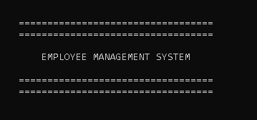

**2: Login Panel**

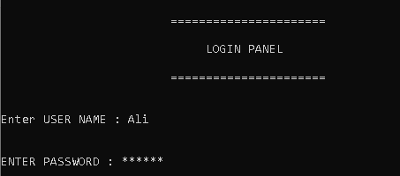

**3: Control Panel**

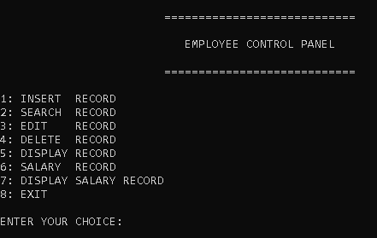

**4: Insert Record**

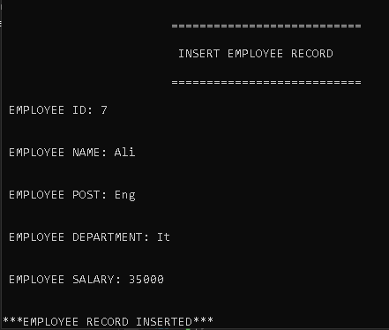

**5: Search Record**

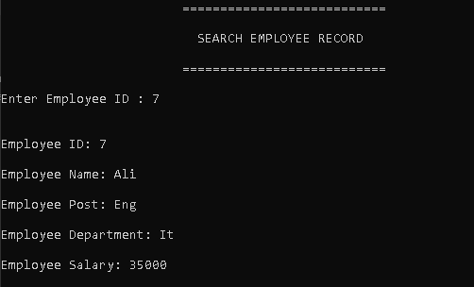

**6: Delete Record**

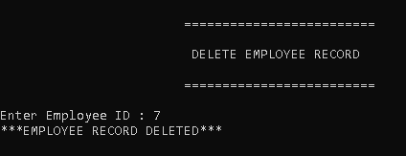

**7: Edit Record**

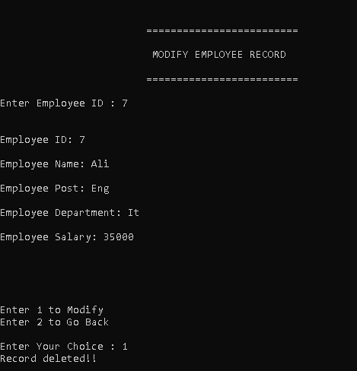

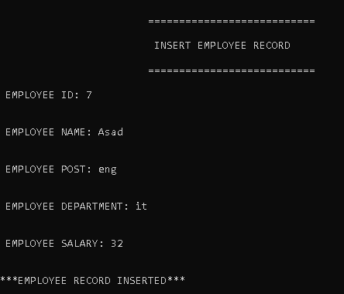

**8: Display Record**

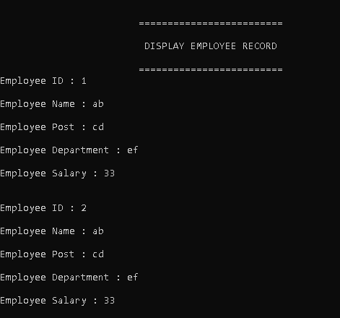

**9: Salary Record**

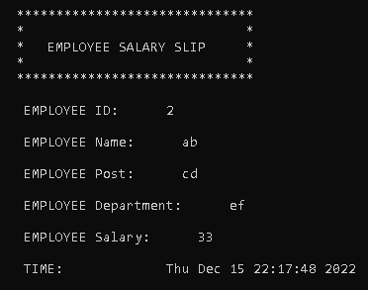

**10: Display Salary Record**

